ELASTIC LOAD BALANCER

ELB (Elastic Load Balancer) is like a traffic controller for your website. It makes sure that when lots of people visit your site, their requests get spread out across multiple servers so that no single server gets overloaded. This helps keep your site running smoothly, even when lots of people are using it at the same time.

# TYPES OF ELB

1. Application Load Balancer (ALB) o Best for handling HTTP and HTTPS traffic.
   * Operates at the application layer (Layer 7) of the OSI model.
   * Can route requests based on the content of the request (e.g., URL, host header).
2. Network Load Balancer (NLB) o Best for handling TCP, UDP, and TLS traffic. o Operates at the transport layer (Layer 4) of the OSI model.
   * Suitable for high-performance and low-latency applications
3. Classic Load Balancer (CLB) o The original ELB, supporting both HTTP/HTTPS and TCP traffic.
   * Operates at both Layer 4 and Layer 7, but offers fewer features compared to ALB and NLB.
   * Best for simple load balancing needs \\

# CREATING A LOAD BALANCER

**STEP1**: First we have to sign in to the aws console

**STEP2:** Creating an EC2 instance and select operating system as linux and AMI id as amazon linux2

AMI

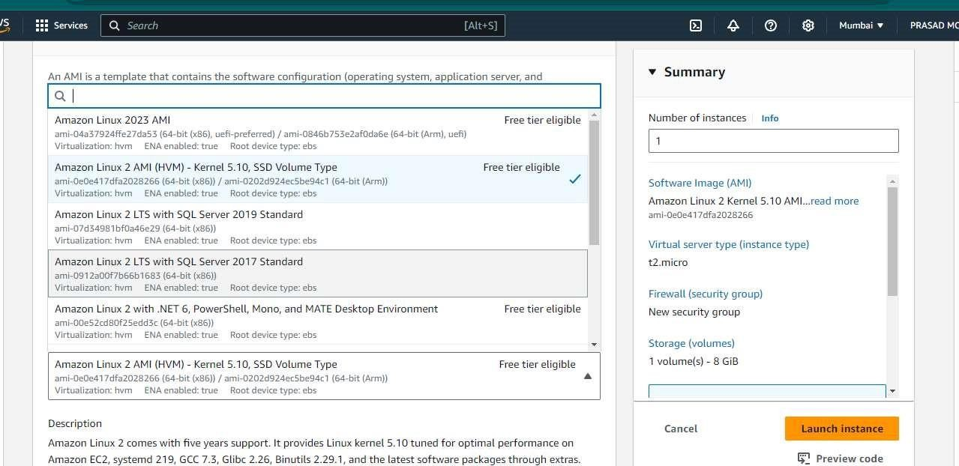

**STEP3**: Now edit the network settings by giving ALL TCP and ANYWHERE in the inbound rules.

Then launch the ec2 instance

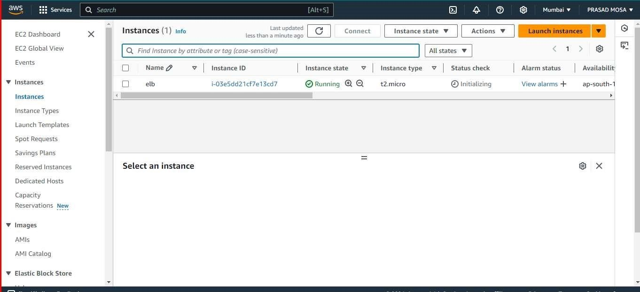

**STEP4**: Now connect to the instance with gitbash or mobaxterm or putty

**STEP5**: Run the following commands

1. sudo su
2. yum update ?y
3. yum install httpd ?y

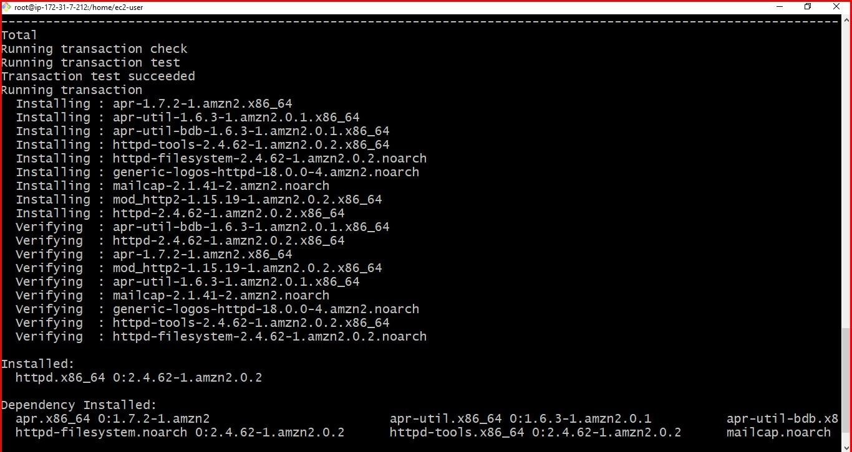

Now the screen shows that the server has been installed successfully

1. service httpd start.

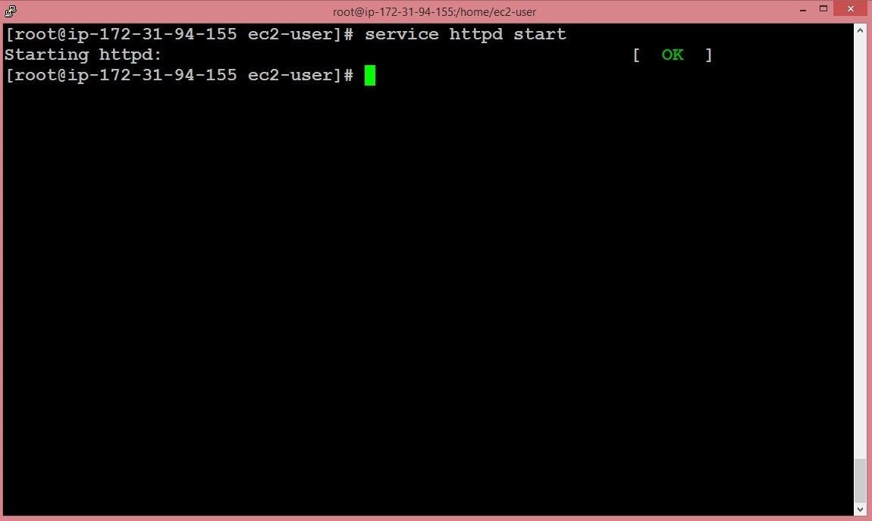

The service has been started with this command

1. cd /var/www/html: moving to the html directorY
2. nano index.html: Now, we are going to create nano healthcheck.html file.

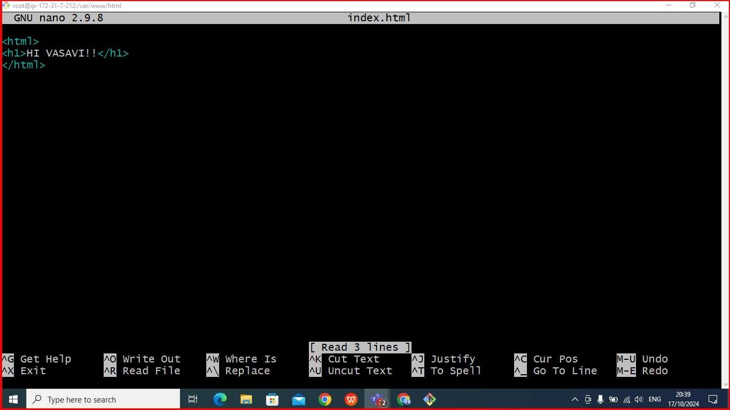

1. nano healthcheck.html :

Now, we are going to create nano healthcheck.html

file.

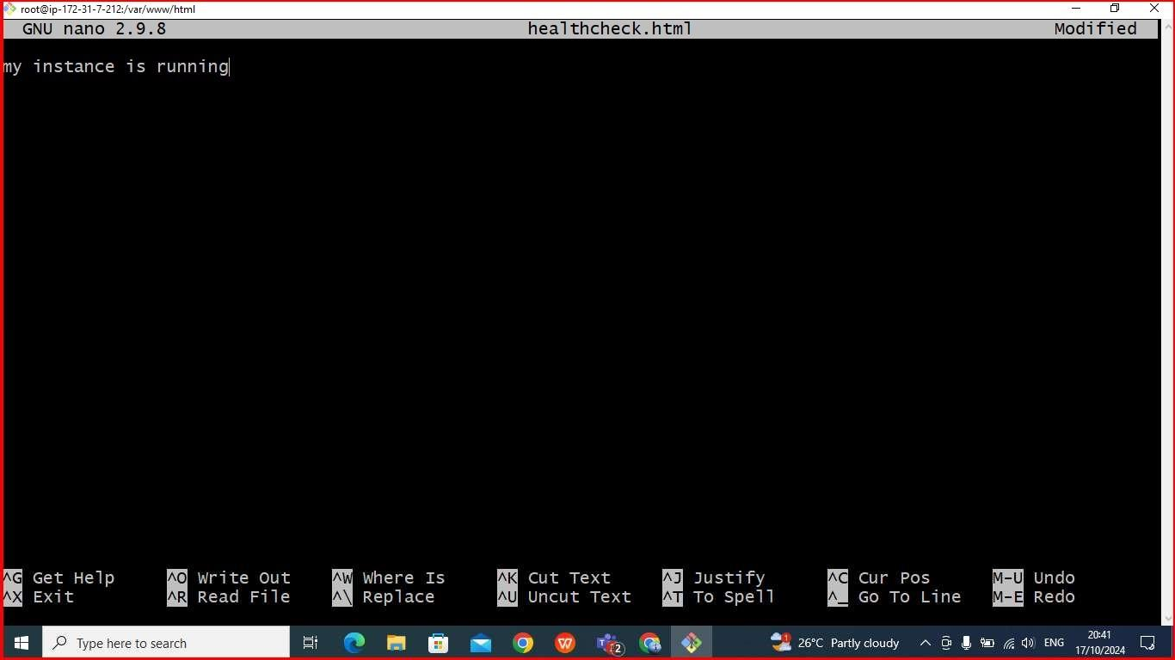

**STEP6:** Move to the EC2 service, click on the Load Balancer appearing on the left side of the console.

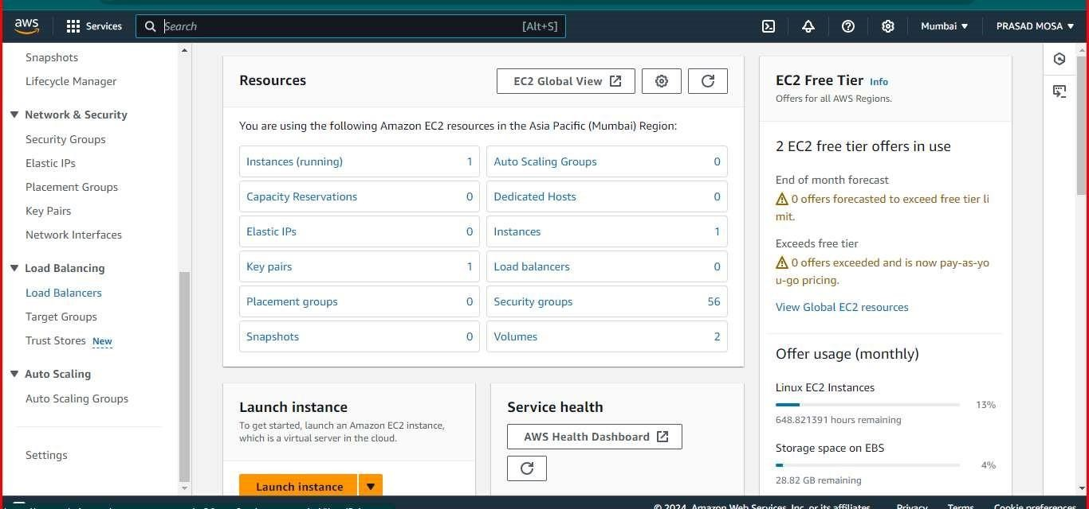

**STEP7**: Create a load balancer by selecting claasic load balancer and click on create

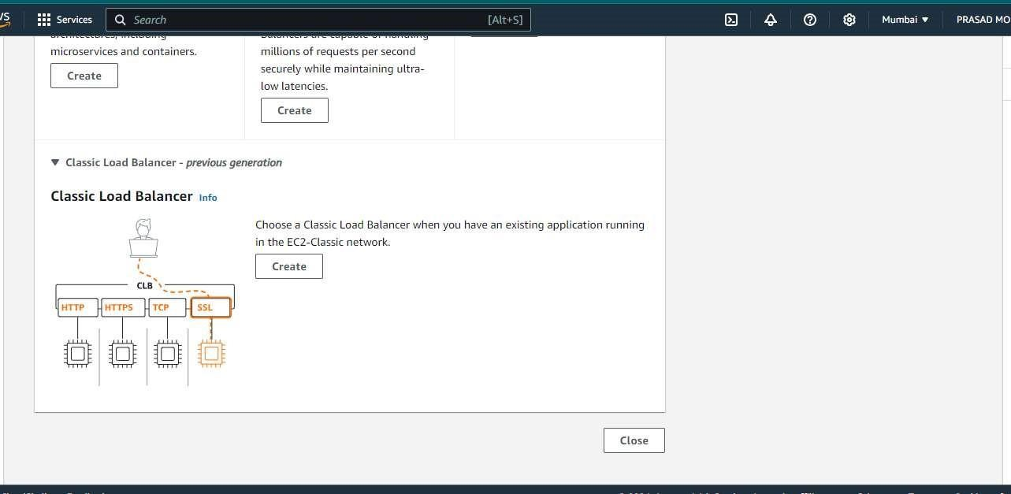

**STEP8**: Fill the basic configuration details

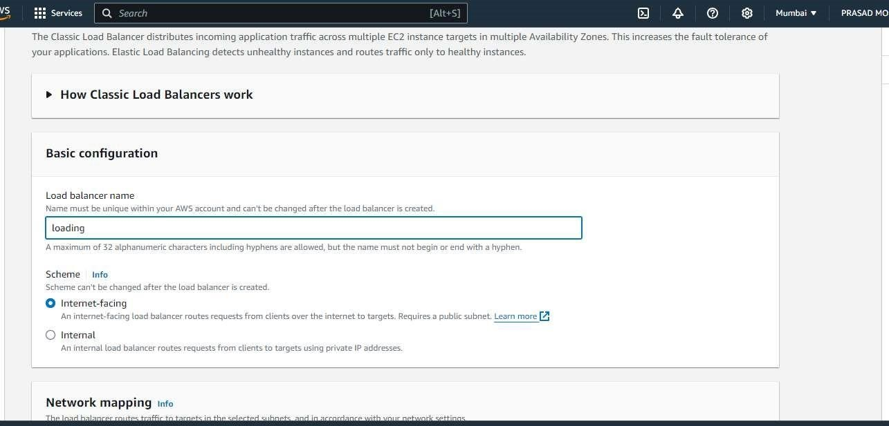

**STEP9**: Coming to the network mapping we will select the following availability zones

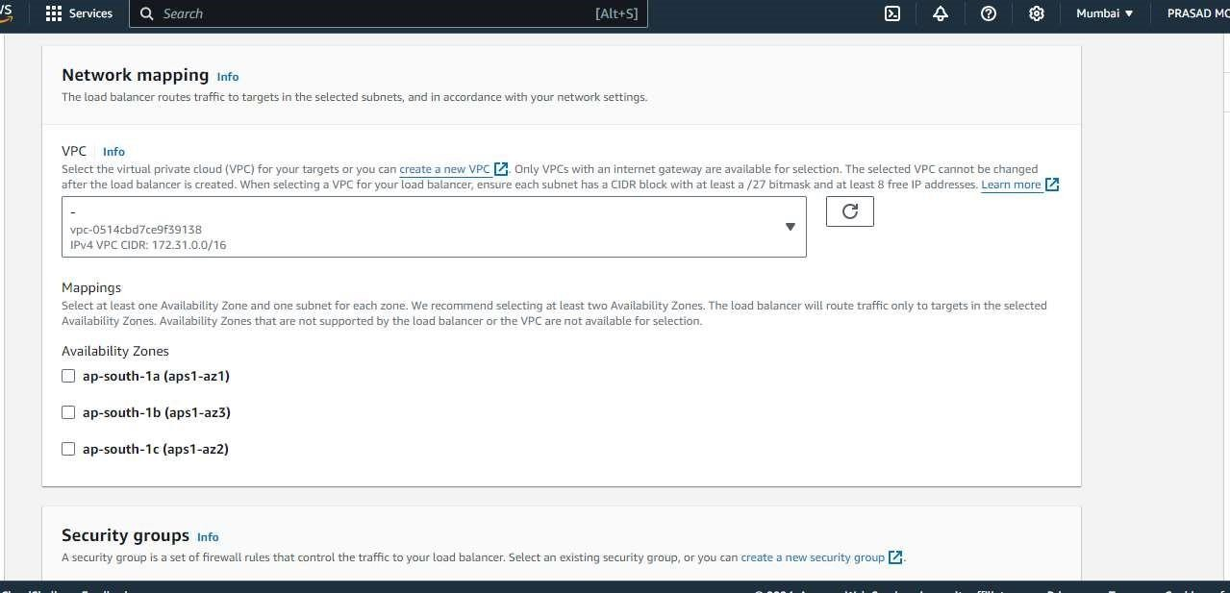

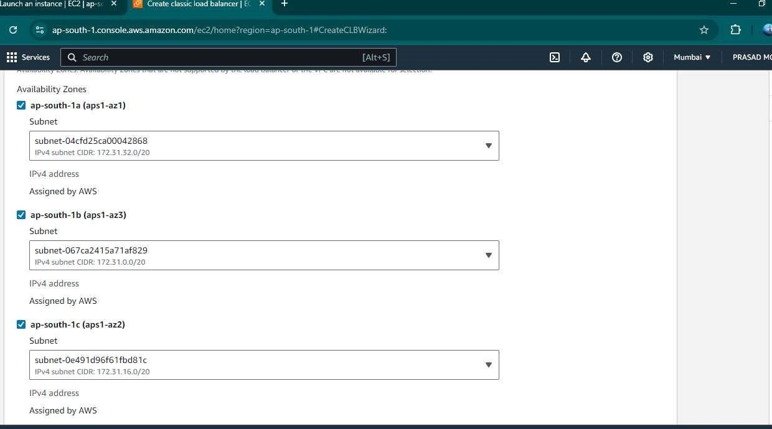

**STEP10**: Select the default security group

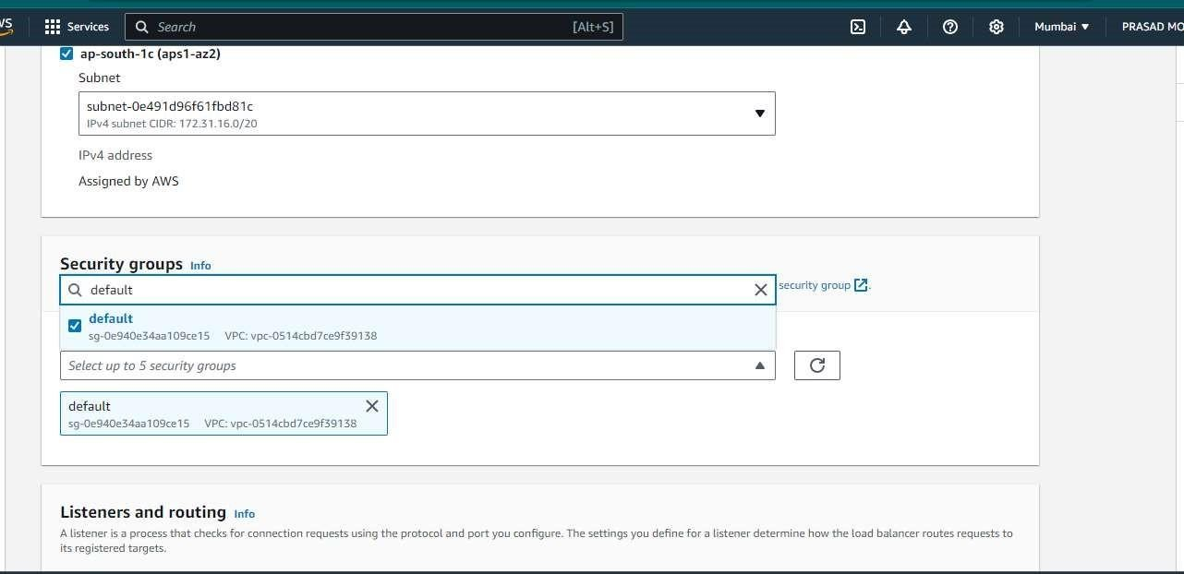

**STEP11**: In the instances section we have to add instance that we have created

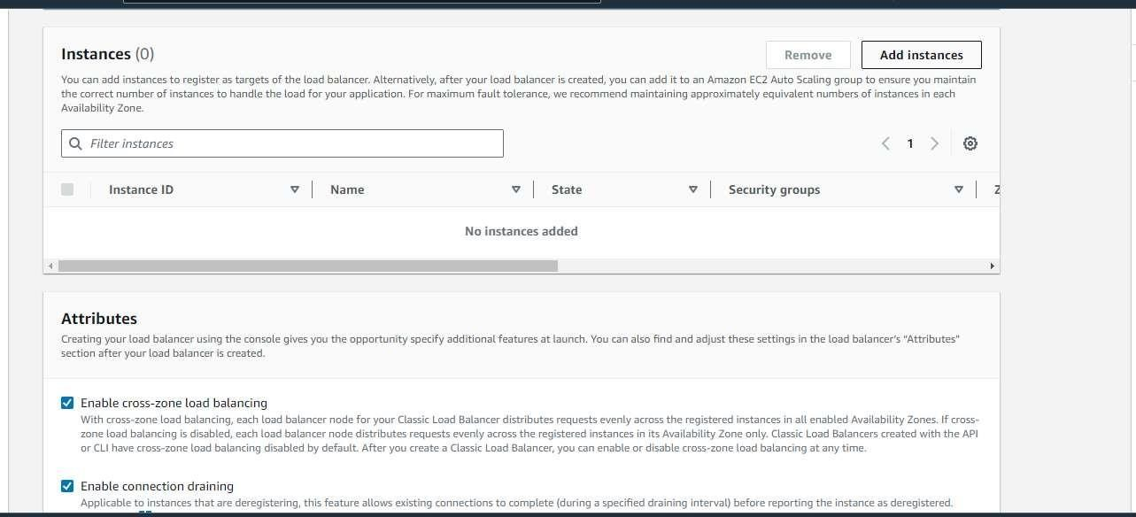

**SEP12:** Added ec2 instance

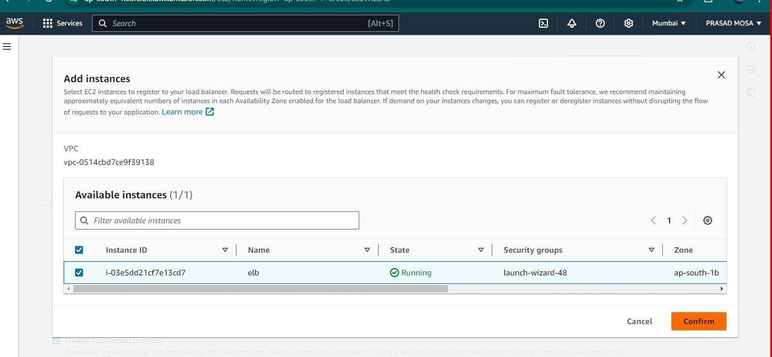

**STEP13**: Then click on create load balancer

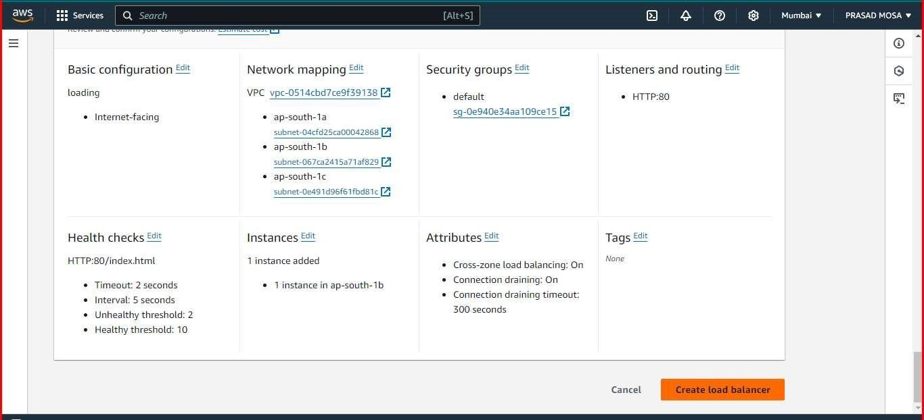

**o STEP14**: When we check the status of an instance, the status appears as OutOfService.

Then after 2mins it appears as in-service

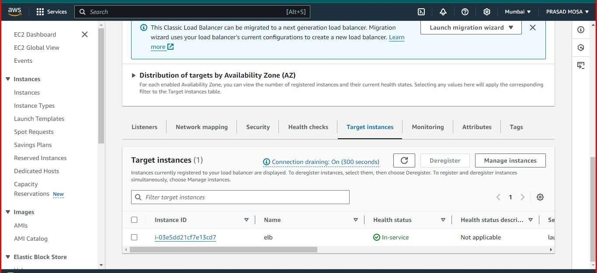

**STEP15**: Copy the public ipv4 dns and paste it web browser then it will show the following output



**Conclusion**: Following the above steps we have created Elastic Load Balancer